**Java Project(GUI)**

**Avinash(AP1911010513)**

**Kishwar Parveen(AP19110010545)**

**Harika(AP19110010499)**

**Project title**

**Food Waste Management**

**Synopsis**

**Project title**

**Food Waste Management.**

**Aim / Objective**

**To reduce the food wastage**

**Technologies used**

**\* There will be a interface asking by the user to enter the details of the**

**Location and food then after getting the details.**

**\* There is an another interface showing the details given by the user and**

**then the manager will go to that location and collect the food, then he**

**will distribute to the poor people, after that he will enter the details of**

**the location where he has distributed the food.**

**Assumption taken**

**5.Details handled**

**details of user location, details of food which is given by the user, details of location and person name where the Manager distributed food,**

**6. Simple Scenario**

**\* Now-a-days everyone enjoys different kinds of functions with a lot of**

**food and another products and most of the people are wasting foods for**

**Various kinds of reasons.**

**\* when we go to restaurants, parties etc are the simple scenarios.**

**7. who can we use this application in real life**

**This application is developed for the purpose of users can give the waste**

**food to the needy people who don't have proper food available due to many reasons. When the users are living the place where they make a request through this interface to fill the details of a particular area, some manager will assign them and take food to the needy people, so this can reduce food waste and help poor people.**

**LOGIN PAGE**

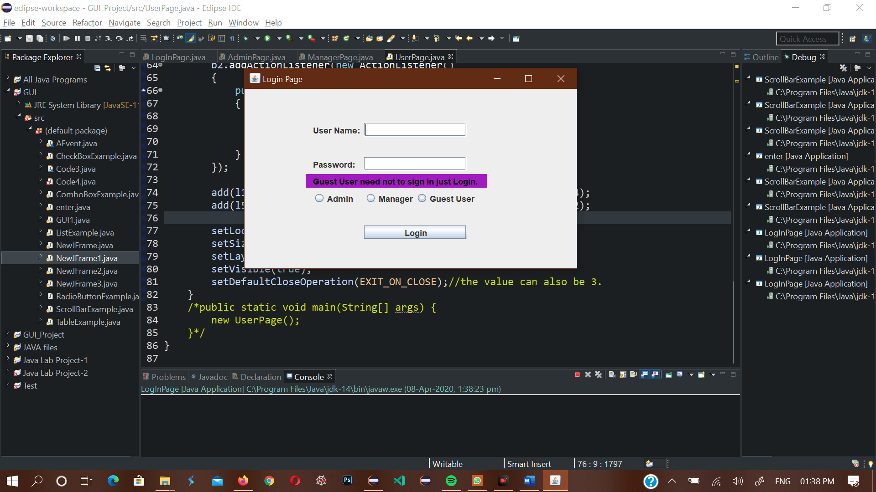

import java.awt.*;

import java.awt.event.ActionEvent;

import java.awt.event.ActionListener;

import javax.swing.*;

public class LogInPage extends JFrame

{

JFrame frame;

JPanel panel1,panel2,fpanal;

JTextFielduiField;

JPasswordFieldpwField;

JLabeluiJLabel,pwJLabel,temp1JLabel,temp2JLabel;

JButtonsuButton;

JRadioButton r1,r2,r3;

public LogInPage()

{

frame=new JFrame();

setTitle("Login Page");

fpanal=new JPanel();

fpanal.setBounds(0,0,500,300);

fpanal.setBackground(new Color(161,27,192));

uiJLabel=new JLabel("User Name: ");

uiField=new JTextField();

uiJLabel.setBounds(100,50,75,20);

uiField.setBounds(175,50,150,20);

pwJLabel=new JLabel("Password: ");

pwField=new JPasswordField();

pwJLabel.setBounds(100,100,75,20);

pwField.setBounds(175,100,150,20);

temp1JLabel=new JLabel("Guest User need not to sign in just Login.");

temp1JLabel.setBounds(100,125,250,20);

temp1JLabel.setForeground(new Color(0,0,0));

panel1=new JPanel();

panel1.setBounds(90,125,265,20);

panel1.setBackground(new Color(161,27,192));

panel1.add(temp1JLabel);

temp2JLabel=new JLabel("Select any option");

temp2JLabel.setVisible(false);

temp2JLabel.setBounds(200,230,150,20);

panel2=new JPanel();

panel2.setBounds(150,230,200,20);

panel2.setBackground(new Color(238,15,15));

panel2.setVisible(false);

panel2.add(temp2JLabel);

r1=new JRadioButton("Admin");

r1.setBounds(100,150,75,20);

r2=new JRadioButton("Manager");

r2.setBounds(175,150,75,20);

r3=new JRadioButton("Guest User");

r3.setBounds(250,150,100,20);

ButtonGroupbGroup=new ButtonGroup();

bGroup.add(r1);bGroup.add(r2);bGroup.add(r3);

suButton=new JButton("Login");

suButton.setBounds(175,200,150,20);

suButton.addActionListener(new ActionListener()

{

public void actionPerformed(ActionEvent e)

{

if(r1.isSelected())

{

String u="admin";

String p="root";

temp2JLabel.setVisible(false);

panel2.setVisible(false);

if(u.equals(uiField.getText()) &&p.equals(new String(pwField.getPassword())))

{

dispose();

new AdminPage();

}

else

{

JOptionPane.showMessageDialog(frame, "Invalid Password");

}

}

else if(r2.isSelected())

{

String u="manager";

String p="root";

temp2JLabel.setVisible(false);

panel2.setVisible(false);

if(u.equals(uiField.getText()) &&p.equals(new String(pwField.getPassword())))

{

dispose();

new ManagerPage();

}

else

JOptionPane.showMessageDialog(frame, "Invalid Password");

}

else if(r3.isSelected())

{

dispose();

new UserPage();

temp2JLabel.setVisible(false);

panel2.setVisible(false);

}

else

{

panel2.setVisible(true);

temp2JLabel.setVisible(true);

}

}

});

add(uiJLabel);add(uiField);add(pwJLabel);add(pwField);add(suButton);

add(r1);add(r2);add(r3);add(temp1JLabel);add(temp2JLabel);

add(panel1);add(panel2);

setLocation(350, 100);

setSize(500,300);

setLayout(null);

setVisible(true);

setDefaultCloseOperation(EXIT_ON_CLOSE);

}

public static void main(String[] args)

{

new LogInPage();

}

}

**Admin Page**

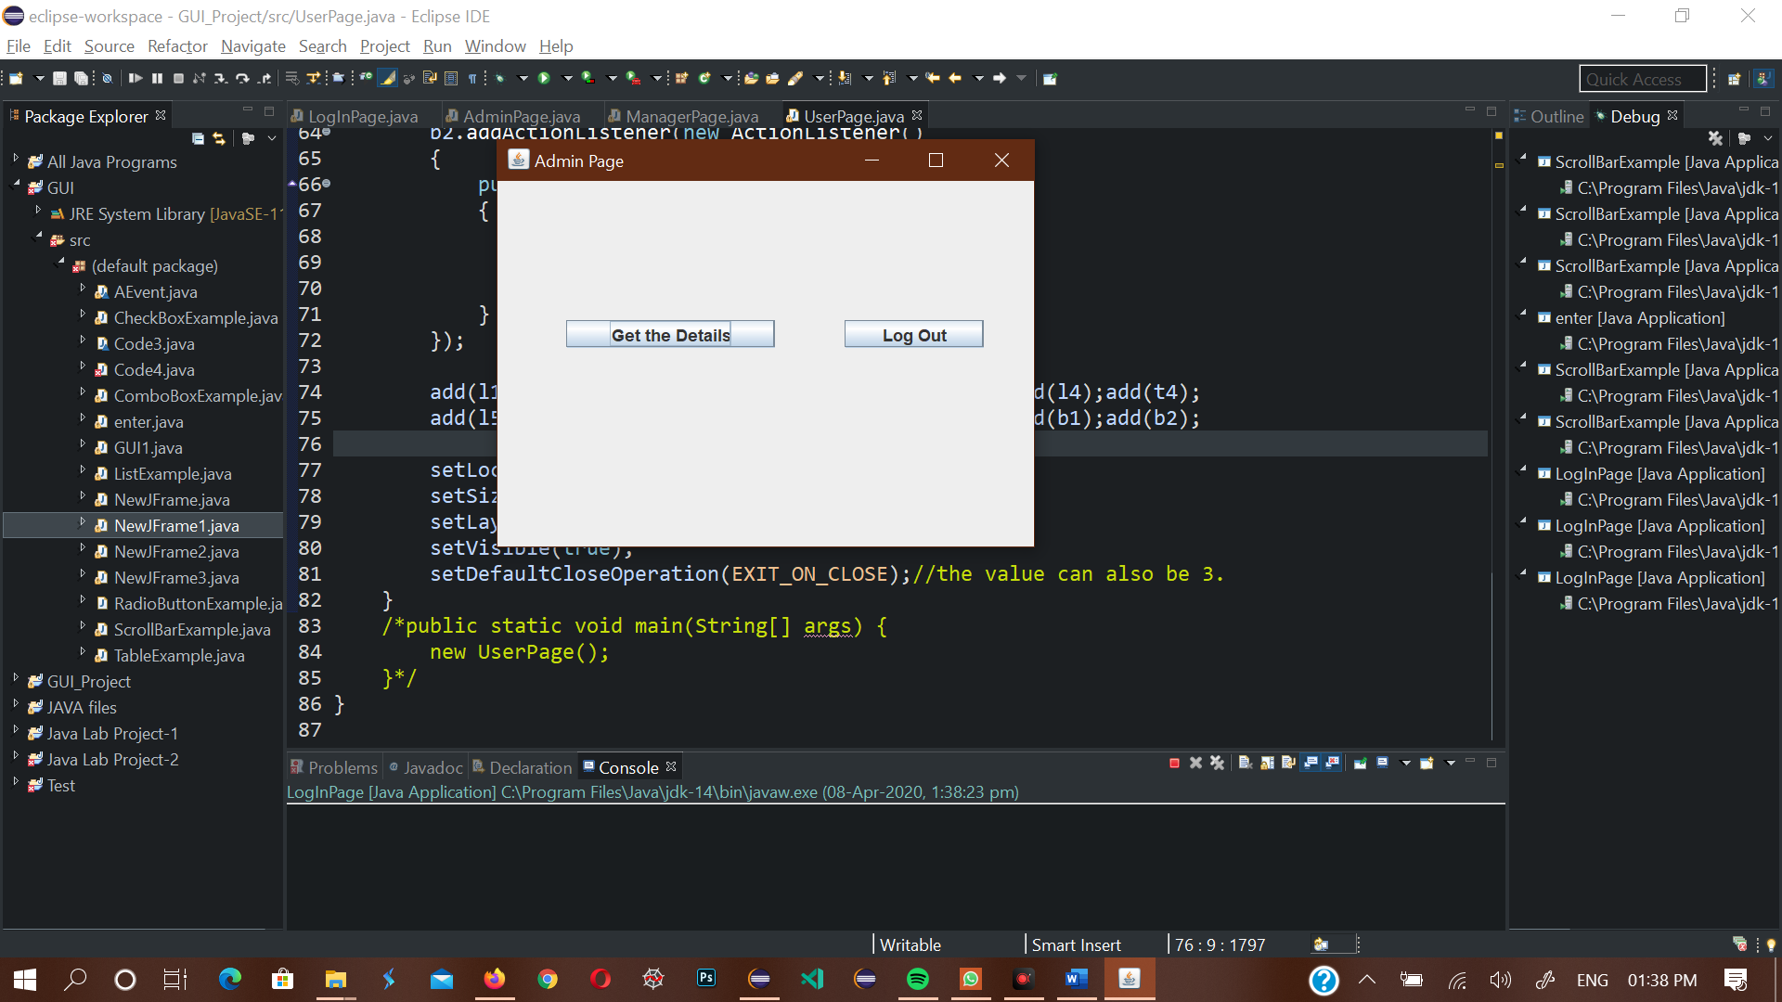

importjavax.swing.*;

importjava.awt.*;

importjava.awt.event.ActionEvent;

importjava.awt.event.ActionListener;

publicclassAdminPageextendsJFrame

{

JFrameaframe;

JLabellabel;

JButtonb1,b2;

publicAdminPage()

{

aframe=newJFrame();

setTitle("Admin Page");

b1=newJButton("Get the Details");

b1.setBounds(50,100,150,20);

b2=newJButton("Log Out");

b2.setBounds(250,100,100,20);

b2.addActionListener(newActionListener()

{

publicvoidactionPerformed(ActionEvente)

{

dispose();

newLogInPage();

}

});

add(b1);add(b2);

setSize(400, 300);

setLocation(350,100);

setLayout(null);//it can also be null.

setVisible(true);

setDefaultCloseOperation(EXIT_ON_CLOSE);//the value can also be 3.

}

/*public static void main(String[] args) {

new AdminPage();

}*/

}

**Manager Page**

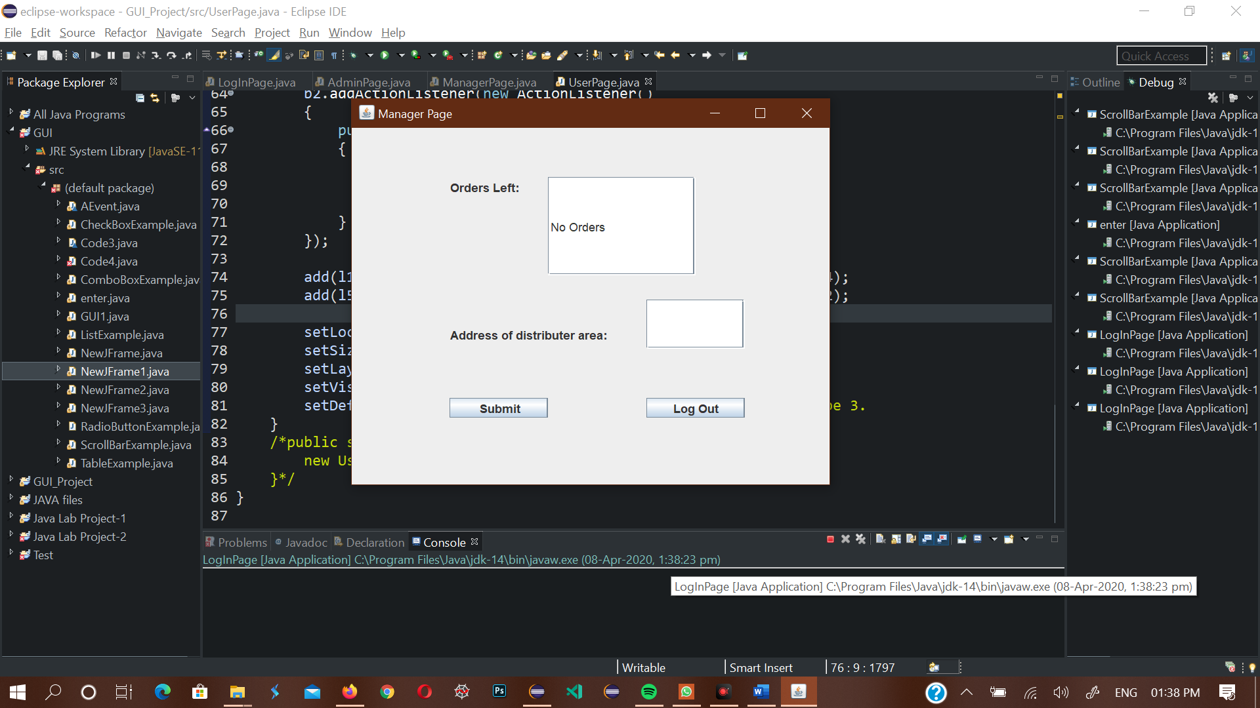

import java.awt.event.ActionEvent;

import java.awt.event.ActionListener;

import javax.swing.*;

public class ManagerPage extends JFrame

{

JFrame f1;

JLabel l1,l2;

JButton b1,b2;

JTextField t1,t2;

public ManagerPage()

{

f1=new JFrame();

setTitle("Manager Page");

l2=new JLabel("Orders Left:");

l2.setBounds(100,50,75,20);

t1=new JTextField("No Orders");

t1.setBounds(200,50,150,100);

l1=new JLabel("Address of distributer area:");

l1.setBounds(100,200,250,20);

t2=new JTextField();

t2.setBounds(300,175,100,50);

b1=new JButton("Submit");

b1.setBounds(100,275,100,20);

b2=new JButton("Log Out");

b2.setBounds(300,275,100,20);

b1.addActionListener(new ActionListener()

{

public void actionPerformed(ActionEvent e)

{

System.out.print("Hello");//just for example.

}

});

b2.addActionListener(new ActionListener()

{

public void actionPerformed(ActionEvent e)

{

dispose();

new LogInPage();

}

});

add(t1);add(l1);add(t2);add(l2);add(b1);add(b2);

setLocation(350,100);

setSize(500, 400);

setLayout(null);//it can also be null.

setVisible(true);

setDefaultCloseOperation(EXIT_ON_CLOSE);//the value can also be 3.

}

/*public static void main(String[] args) {

new ManagerPage();

}*/

}

**User Page**

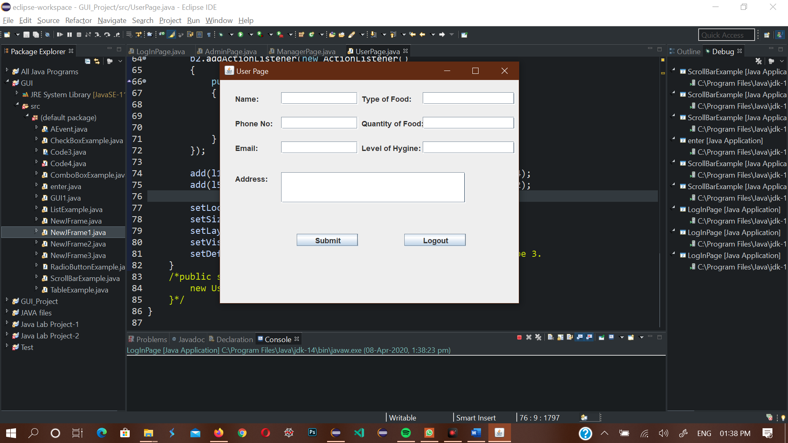

import java.awt.event.ActionEvent;

import java.awt.event.ActionListener;

import javax.swing.*;

public class UserPage extends JFrame

{

JFrameuFrame;

JLabel l1,l2,l3,l4,l5,l6,l7;

JTextField t1,t2,t3,t4,t5,t6,t7;

JButton b1,b2;

public UserPage()

{

uFrame=new JFrame();

setTitle("User Page");

l1=new JLabel("Name:");

t1=new JTextField();

l1.setBounds(25,20,50,20);

t1.setBounds(100,20,125,20);

l2=new JLabel("Type of Food:");

t2=new JTextField();

l2.setBounds(230,20,150,20);

t2.setBounds(330,20,150,20);

l3=new JLabel("Phone No:");

t3=new JTextField();

l3.setBounds(25,60,75,20);

t3.setBounds(100,60,125,20);

l4=new JLabel("Quantity of Food:");

t4=new JTextField();

l4.setBounds(230,60,150,20);

t4.setBounds(330,60,150,20);

l5=new JLabel("Email:");

t5=new JTextField();

l5.setBounds(25,100,50,20);

t5.setBounds(100,100,125,20);

l6=new JLabel("Level of Hygine:");

t6=new JTextField();

l6.setBounds(230,100,150,20);

t6.setBounds(330,100,150,20);

l7=new JLabel("Address:");

t7=new JTextField();

l7.setBounds(25,150,150,20);

t7.setBounds(100,150,300,50);

b1=new JButton("Submit");

b2=new JButton("Logout");

b1.setBounds(125,250,100,20);

b2.setBounds(300,250,100,20);

b1.addActionListener(new ActionListener()

{

public void actionPerformed(ActionEvent e)

{

System.out.println("Hello");//just for example

}

});

b2.addActionListener(new ActionListener()

{

public void actionPerformed(ActionEvent e)

{

dispose();

new LogInPage();

}

});

add(l1);add(t1);add(l2);add(t2);add(l3);add(t3);add(l4);add(t4);

add(l5);add(t5);add(l6);add(t6);add(l7);add(t7);add(b1);add(b2);

setLocation(350, 100);

setSize(500, 400);

setLayout(null);

setVisible(true);

setDefaultCloseOperation(EXIT_ON_CLOSE);//the value can also be 3.

}

/*public static void main(String[] args) {

new UserPage();

}*/

}